CARDIOVASCULAR SYSTEM: Heart (Chapter 20)

Cardiovascular System:
Pulmonary circuit: right ventricle → lungs → left atrium
Systemic circuit: left ventricle → body → right atrium

Arteries = away from heart
Veins = toward heart
Capillaries = exchange vessels in between

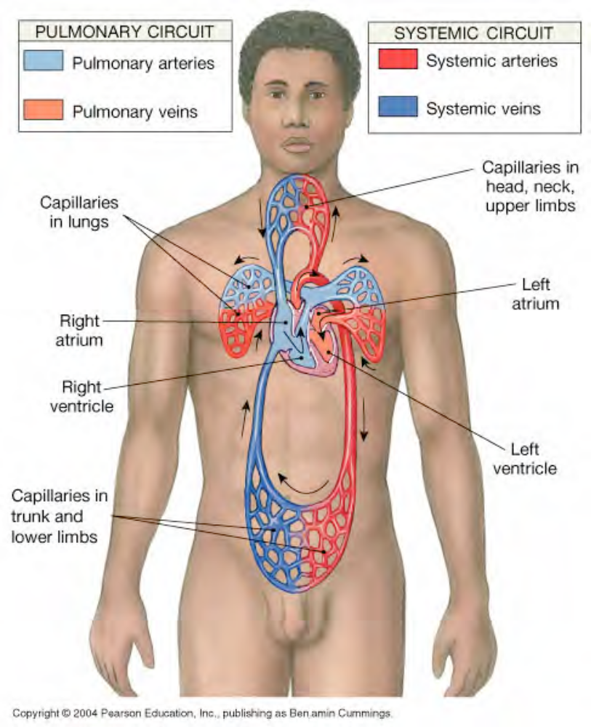

Heart
-left of midline, between 2nd rib and 5th intercostal space, posterior to sternum, in pericardial
cavity in mediastinum

-heart is fist sized, < 1 lb, beats 100,000 times/day moving 8000 L blood/day

-surrounded by pericardium (serous-thin & transparent and fibrous-tough & fibrous)

-serous membranes (visceral & parietal) secrete pericardial fluid, reduce friction

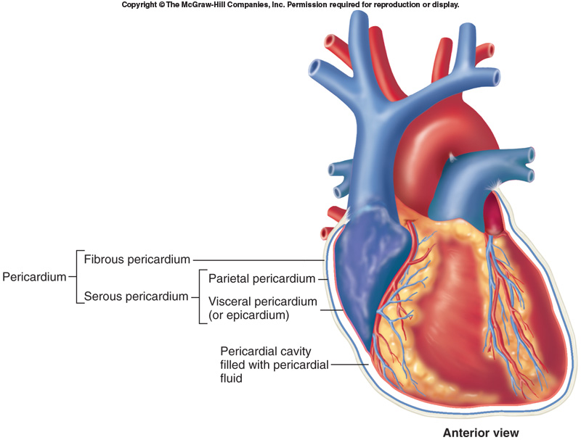
Disorder:
Pericarditis = inflammation of pericardium, usually due to infection, causes friction

Cardiac tamponade = buildup of fluid in pericardial space, restricts heart movement
usually due to trauma or myocardial infarction

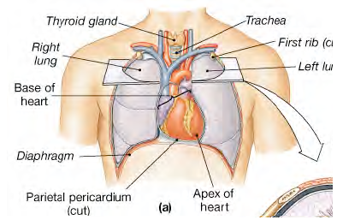

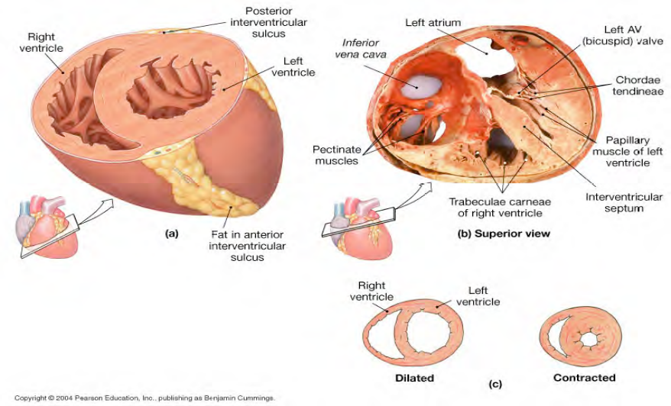
Four Chambers:

2 Atria:

-superior, thin walls, smooth posterior walls internally, pectinate muscles (ridges) anteriorly

-each has expandable flap called an auricle that can be seen anteriorly between each atrium
and ventricle

-left and right separated by interatrial septum

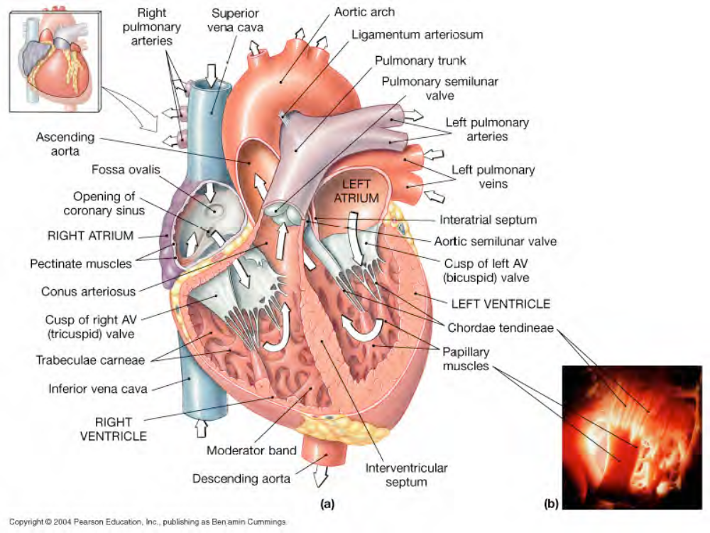
2 Ventricles:

-inferior, thick walls, lined with trabeculae carneae (muscular ridges)

-left and right separated by interventricular septum

Left ventricle 3X thicker, 5X more friction while pumping, same volume as right

Left is round & opens into the aorta, right is crescent & opens into the pulmonary trunk

External divisions:

-Superior vena cava and inferior vena cava carry blood from body to the right atrium

-Pulmonary veins, 4, carry blood from the lungs to the left atrium

-2 arteries, aorta and pulmonary trunk, exit the heart
-Aorta, carries blood from left ventricle to body
-Pulmonary trunk, carries blood from right ventricle to lungs

-Coronary sulcus marks division between atria and ventricles

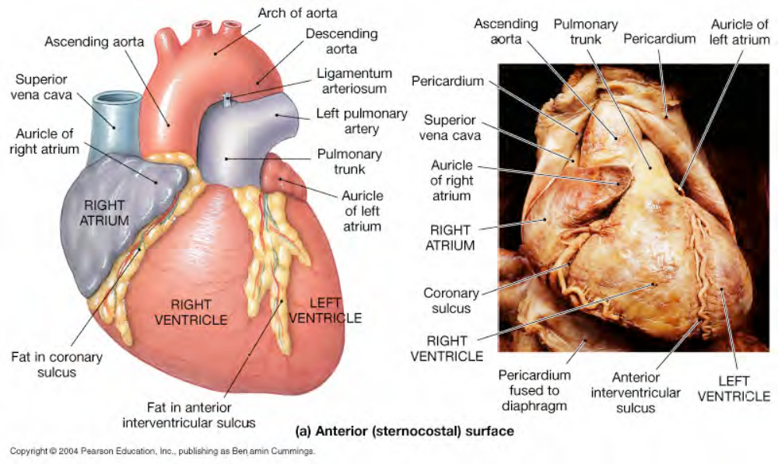

-Anterior interventricular sulcus and posterior interventricular sulcus mark division
between ventricles

*Note: healthy heart has fat covering the sulci
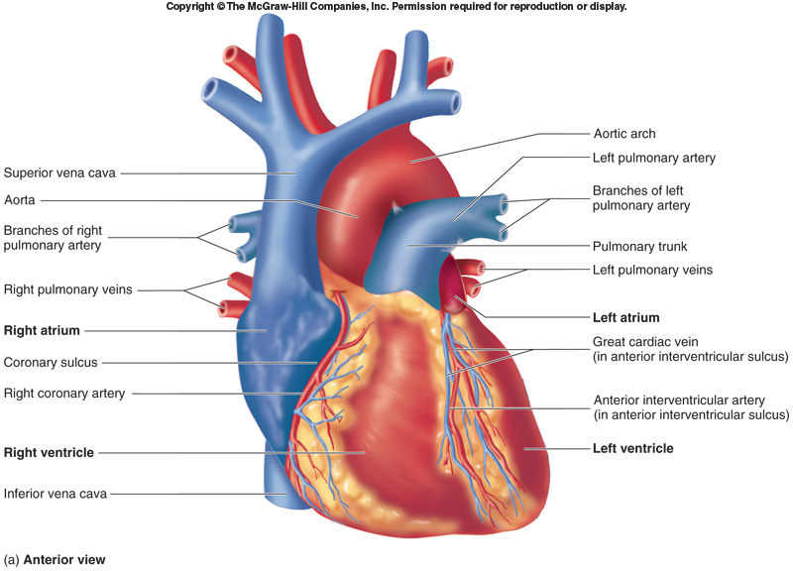

-Arteries supplying blood to the tissue of the heart lie within the coronary sulcus and
interventricular sulci on the surface of the heart:

- Right coronary artery: exits aorta from the right aortic sinus and extends around to the posterior of heart, lies within coronary sulcus, 2 branches:
- Right marginal artery: supply blood to lateral wall of right ventricle
- Posterior interventricular artery: lies in posterior interventricular sulcus, supplies blood to the posterior and inferior part of heart

- Left coronary artery: exits aorta from the left aortic sinus, lies within coronary sulcus, 3 branches:
- Anterior interventricular artery (left anterior descending artery): extends inferiorly in the anterior interventricular sulcus, supplies blood to anterior part of heart
- Left marginal artery: supplies blood to lateral wall of left ventricle
- Circumflex artery: extends around to posterior side of heart in coronary sulcus, supplies blood to the posterior wall of heart

-Veins that drain tissues of the heart:
- Great cardiac vein: drains left side
- Small cardiac vein: drains right side

Both the great cardiac vein and the small cardiac vein converge toward the posterior part of coronary sulcus and empty into a large venous cavity called:
coronary sinus, empties in the right atrium

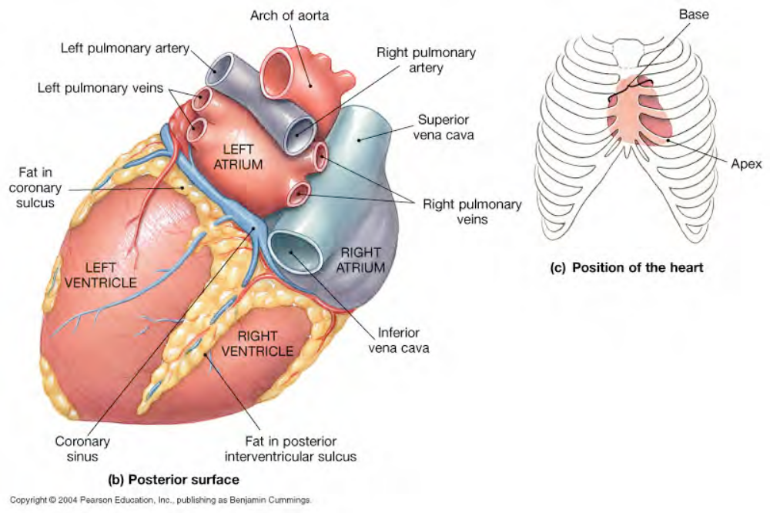

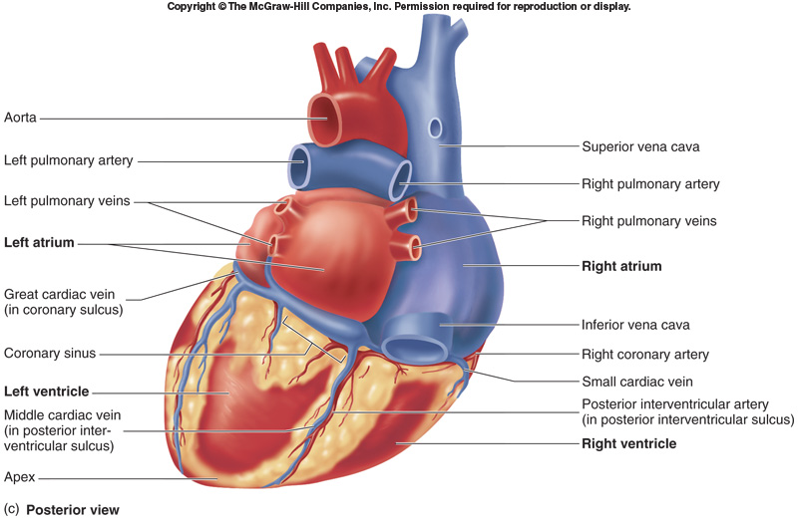

Heart Wall Layers:

1. Epicardium (thin) - visceral pericardium: serous membrane with loose CT attached to
myocardium
- outer surface of the heart

2. Myocardium (thick) - cardiac muscle tissue with CT, vessels and nerves
- responsible for the heart’s ability to contract

3. Endocardium (thin) - simple squamous epithelium lining with basal lamina; continuous with
endothelium of blood vessels
-smooth inner surface------allows blood to move easily through the heart

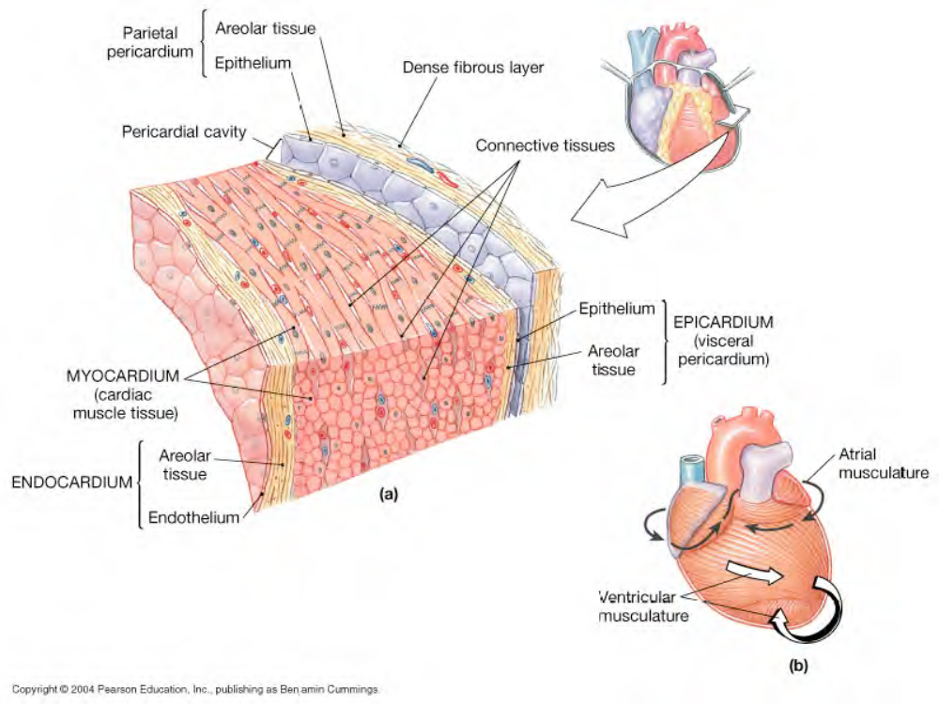

Cardiac Muscle Tissue
-muscle cells = cardiocytes (elongated & multi nucleated)

-uses actin and myosin sliding filaments to contract

-rich in mitochondria, resists fatigue but dependent on aerobic respiration

-cells connected by intercalated discs = desmosomes (hold cells together) + gap junctions (allow action potentials to pass from one cell to adjacent cells)
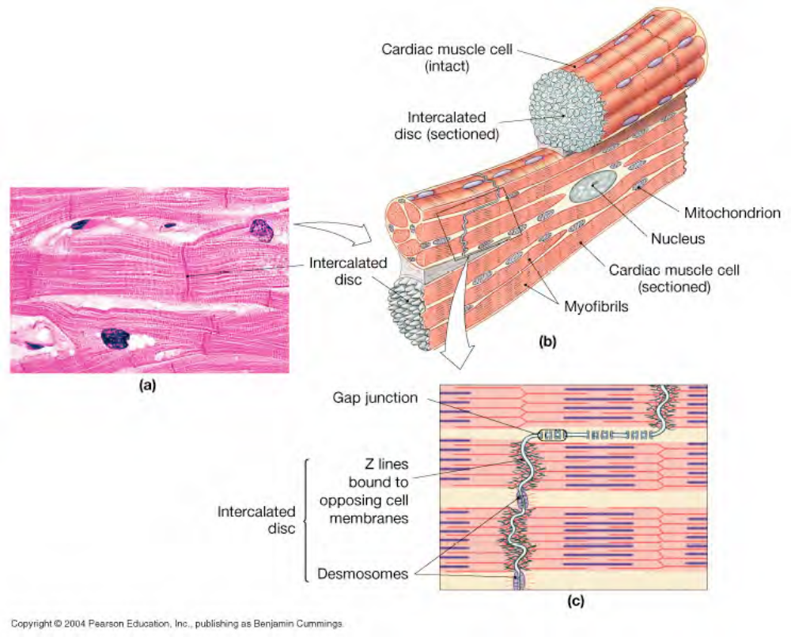
-contraction is all or none------------behaves as a single unit

-longer contractile phase than skeletal muscle

-skeleton of the heart consists of fibrous CT rings, which surround the heart valves and separate
the atria from the ventricles
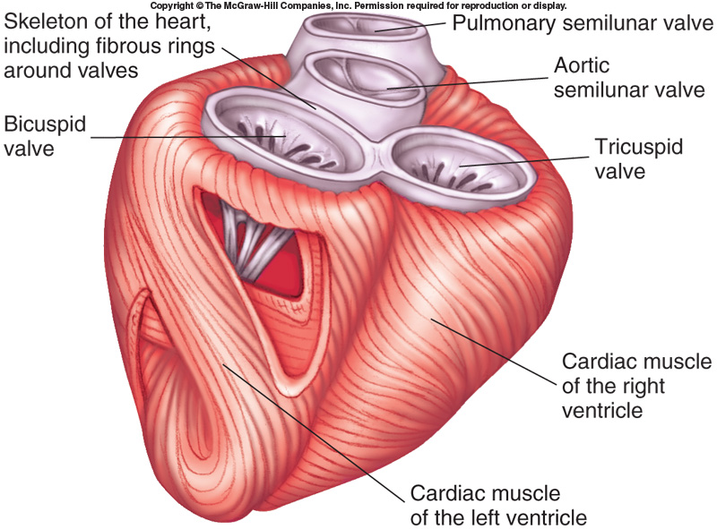
Cardiac muscle attaches to the fibrous connective tissue--------when ventricles contract, a wringing motion is produced & the distance between the apex & base of the heart shortens.
Heart Valves: (one way, prevent backflow)

Atrioventricular valves - between atria and ventricles
(flaps = cusps)
- Tricuspid valve: right side, 3 cusps
- Bicuspid/Mitral valve: left side, 2 cusps

-cusps attached to chordate tendineae (thin, strong connective tissue strings) from papillary muscles ( cone-shaped, muscular pillars) on ventricle wall

-contraction of papillary muscles prevent cusps opening backward during ventricle contraction

-cusps hang loose when ventricles not contracting, allow ventricles to fill with blood
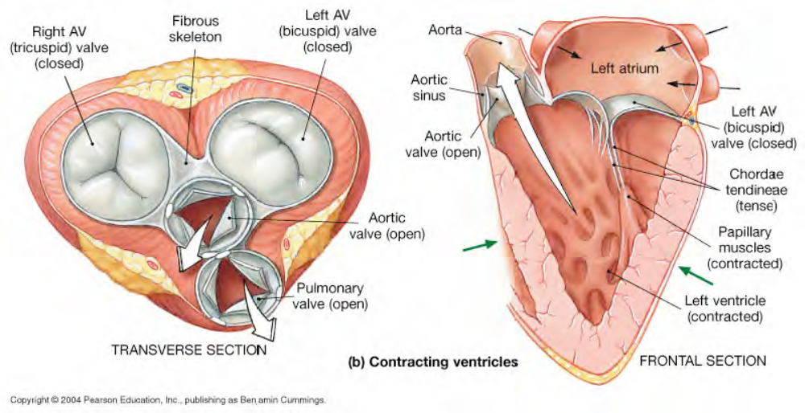

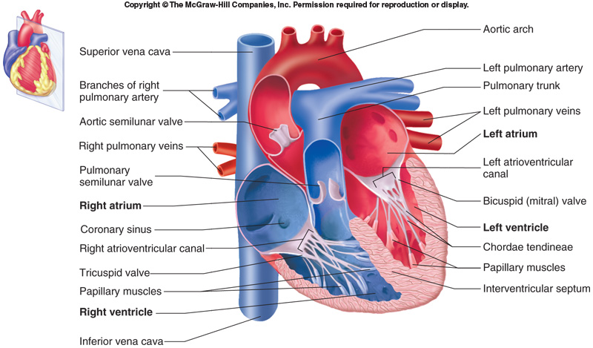
Semilunar valves - between ventricles and arteries
- Aortic valve
- Pulmonary valve

-3 cusps
-no chordae tendineae or muscles

-forced open by blood from ventricular contraction

-snap closed to prevent backflow
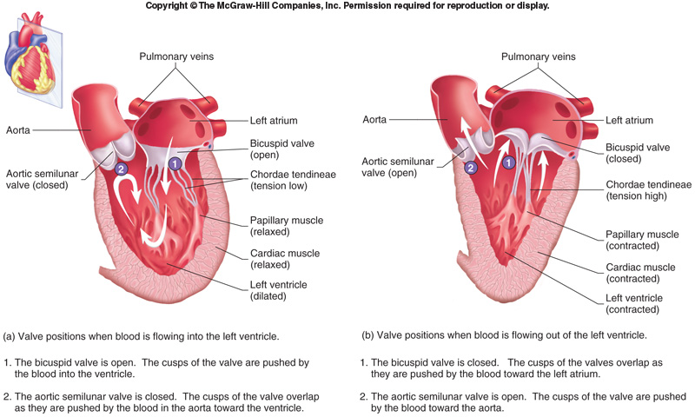

Disorder:

Valvular heart disease - valve function deteriorates to extent that heart cannot maintain adequate circulation
Ex. Rheumatic fever - childhood reaction to streptococcal infection, chronic carditis (inflammation of the heart), VHD in adult

Heart murmur - leaky valve (audible to Dr.-------swish sound)
Ex. Mitral valve prolapse - murmur of left AV valve, cusps don’t close properly, blood regurgitates back into left atrium

Congestive heart failure - decreased pumping efficiency (diseased valves, damaged muscle), blood backs up, fluid leaks from vessels and collects in lungs and tissues

Blood Flow Through The Heart

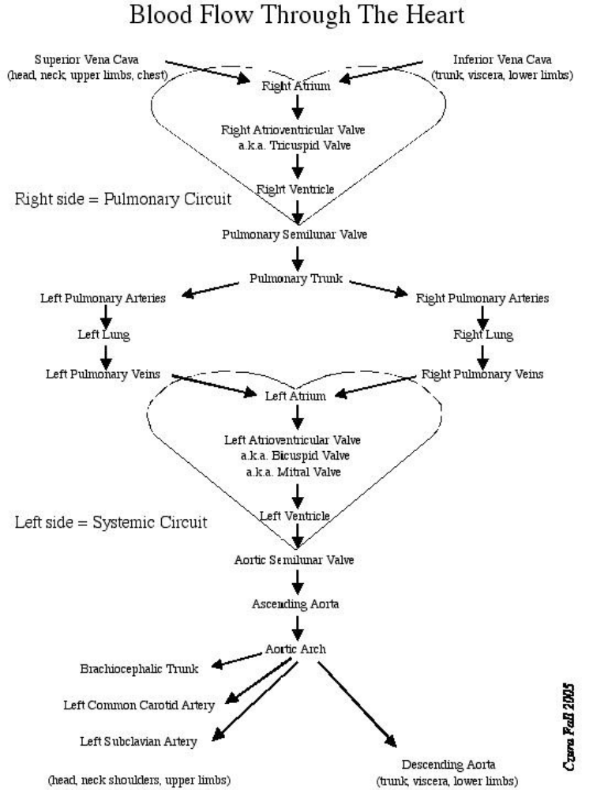

Blood Flow Through The Heart

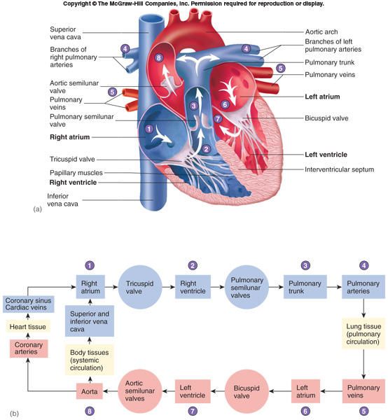

Fetal Heart (adapted to bypass lungs)

-Foramen ovale in right atrium, ~25% of blood bypasses directly the left atrium, closes at birth
leaving scar called fossa ovalis.

- Ductus arteriosus connects pulmonary trunk to aorta, ~90% of blood bypasses lungs,
closes at birth leaving the ligamentum arteriosum

Failure of either to close = poor oxygenation of blood, cyanosis, “blue baby syndrome”

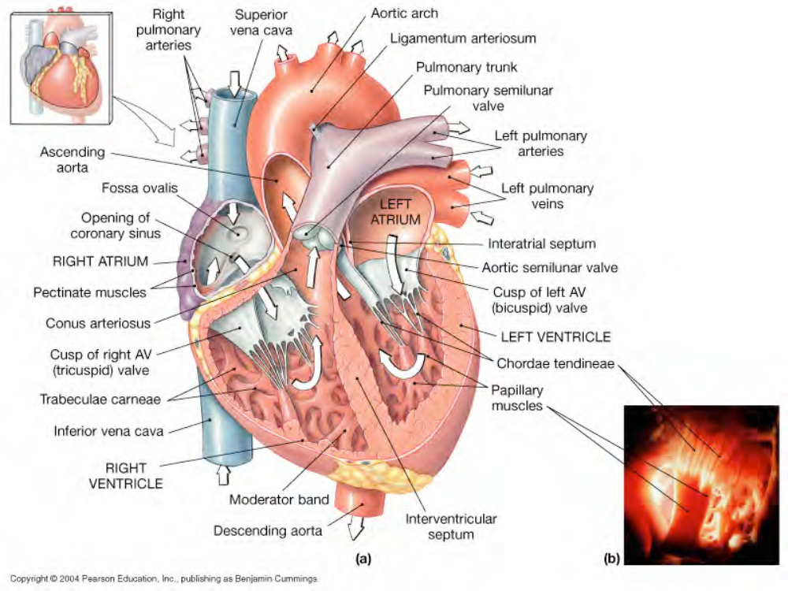

Coronary circulation- is the circulation of blood in the blood vessels of the heart muscle

-heart: <1% body mass, requires 5% of blood

-too thick for diffusion-----------------although blood fills the chambers of the heart, the muscle tissue of the heart (myocardium) is so thick that it requires coronary blood vessels to deliver blood deep into it.

-coronary arteries originate at base of ascending aorta, branch to capillary beds for diffusion
Two types: a. coronary arteries that run on the surface of the heart: epicardial coronary arteries
b. coronary arteries that run deep within the myocardium: subendocardial

-blood returns via cardiac veins (remove deoxygenated blood) that empty into right atrium

* Note: This is the only source of blood supply to myocardium---------that is why blockage of these vessels is so critical.

* Note: Branching is very important because if one coronary artery is obstructed, the second artery is still able to supply oxygenated blood to myocardium.

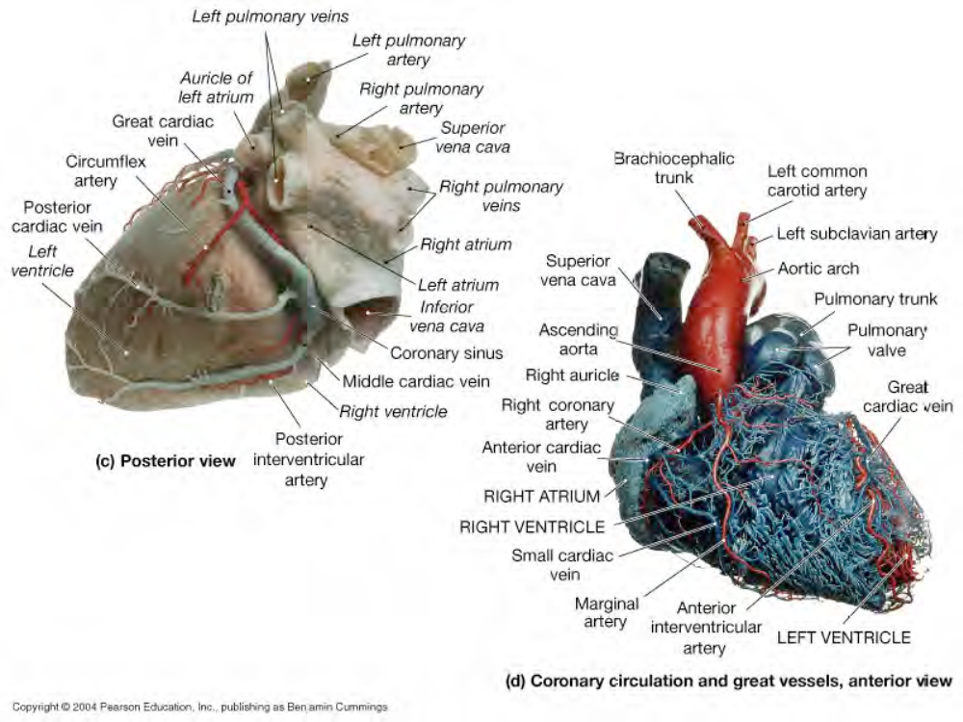

Disorder:

Coronary artery disease -partial or complete block of coronary circulation, results in coronary
Ischemia (insufficiency of oxygen-rich blood)

-Can lead to myocardial infarction (heart attack): heart tissue denied oxygen dies.

-Common symptom of CAD: angina pectoralis pain in the chest, especially during activity, as a result of the ischemia

-Coronary bypass surgery - use healthy veins (from legs) to create anatomoses (direct
connections) around blockages.

-Most people have 4 major coronary arteries: “quadruple bypass”

Heart Beat: Conducting System (relays action potentials through the heart)

- SA node: sinoatrial node. Medial to opening of superior vena cava. The pacemaker. Specialized cardiac muscle cells. Generate spontaneous action potentials. Action potentials pass to atrial muscle cells and to the AV node

- AV node: atrioventricular node. Medial to the right atrioventricular valve. Action potentials conducted more slowly here than in any other part of system. Ensures ventricles receive signal to contract after atria have contracted

- AV bundle: passes through hole in cardiac skeleton to reach interventricular septum

- Right and left bundle branches: extend beneath endocardium to apices of right and left ventricles

- Purkinje fibers: Large diameter cardiac muscle cells with few myofibrils. Many gap junctions. Conduct action potential to ventricular muscle cells

* Note:
- The two nodes (SA & AV) & the conducting bundle (AV bundle) are modified cardiac muscle cells.
- The AV node gives rise to the conducting bundle of the heart, AV bundle (bundle of His).
- The AV bundle divides and forms the right & left bundle branches.
- The terminal branches of the bundle branches are the Purkinje fibers.
- The more gap junctions, the faster the action potential spreads!
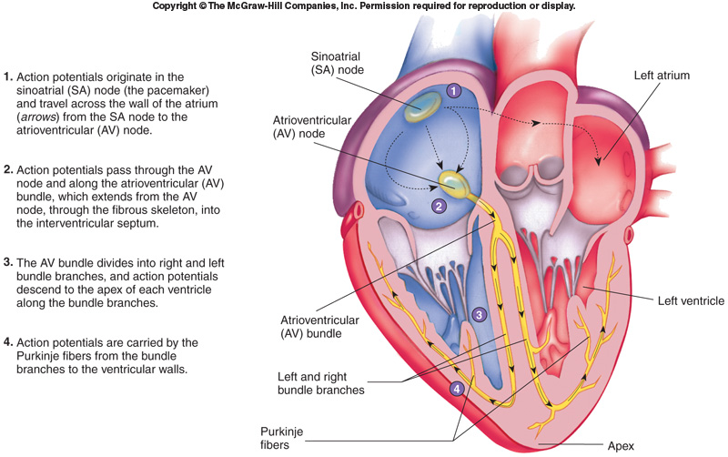

Total time = ~370ms
-Myocardial cells (including nodes) are autorhythmic: depolarize without neural or endocrine
stimulation

-SA node generate action potential spontaneously and at regular intervals and then spread
them through the conducting system to other myocardial cells:

* Note: Under resting conditions, 0.04 second is required for action potentials to travel from the SA node to AV node. Within AV node, action potentials are propagated slowly due to fewer gap junctions--------a delay occurs of 0.11 second from the time action potentials reach the AV node until they pass to the AV bundle. This allows for the completion of the atrial contraction before ventricular contraction begins.

Autorhythmicity: SA Node Action Potential

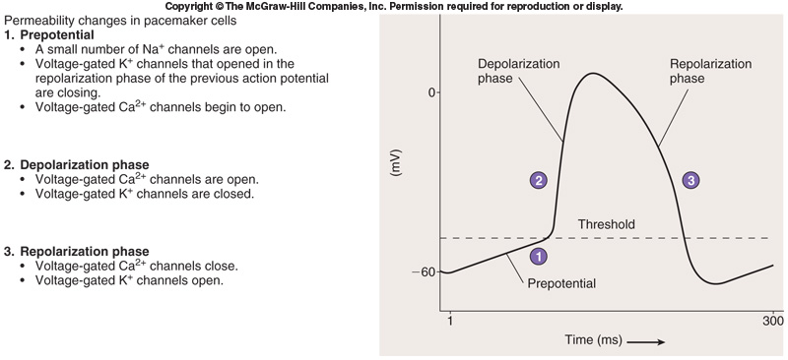

-Prepotential: spontaneously developing local potential. Results in generation of action
potentials in the SA node

-cells of nodes cannot maintain resting membrane potential, drift to depolarization:
SA node 80-100 action potentials/min (“natural pacemaker”)
AV node 40-60 action potentials/min

-Resting rate (sinus rhythm) ~75bpm set by SA node + parasympathetic stimulation

-Normal average heart rate= ~ 70-80bpm
max = ~230bpm, but inefficient above 180

-Bradycardia = heart rate slower than normal <60

-Tachycardia = heart rate faster than normal >100

-Ectopic focus: is any part of the heart other than the SA node that generates a heartbeat. For example, if the SA node does not function properly, the part of the heart to produce the action potentials at the next highest frequency is the AV node.

-AV node: 40-60 bpm
-AV bundle: 30 bpm

-Calcium Channel Blockers: used clinically in treatment of tachycardia and also used to reduce the amount of work performed by the heart because it causes less calcium to enter the cardiac muscle cells to activate the contractile mechanism.

-Epinephrine & Norepinephrine: increase the heart rate & its force of contraction by opening voltage-gated Ca++ channels.

Electrocardiogram (EKG):
-recording of electrical events of heart

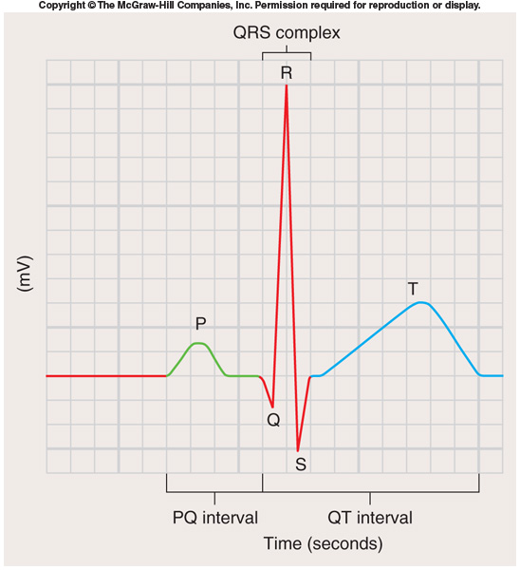

- P wave: depolarization of atrial myocardium and signals onset of atrial contraction

- QRS complex: ventricular depolarization and signals onset of ventricular contraction. Repolarization of atria simultaneously.

- T wave: repolarization of ventricles; precedes ventricular relaxation

- PQ interval or PR interval: 0.16 sec; atria contract and begin to relax, ventricles begin to contract

- QT interval: 0.36 sec; ventricles contract and begin to relax

EKG used to diagnose heart problems:

- P-R longer than 200ms (0.2 sec) = damage to AV node or conducting cells
Total heart block = damaged AV node, no impulses transmitted through, atria and ventricles beat independently (atria fast, ventricles slow)

- Large QRS = enlarged heart

- Q-T longer than 380ms (0.38 sec) = coronary ischemia or myocardial damage

-Cardiac arrhythmias = abnormal patterns of cardiac activity

-Fibrillation = rapid, irregular, out of phase contractions due to activity in areas other than SA
node: defibrillation to stop all activity so SA node can resume control

Cardiac Cycle:
-alternating contraction and relaxation (moves blood through heart)

-Systole = contraction, high pressure, blood gets pushed to next chamber

-Diastole = relaxation, low pressure, chamber fills with blood

↑heart rate = ↓cycle time, ↓diastole time = ↓ time to fill

-Blood moves through circulatory system from areas of higher to lower pressure.
  - Contraction of heart produces the pressure

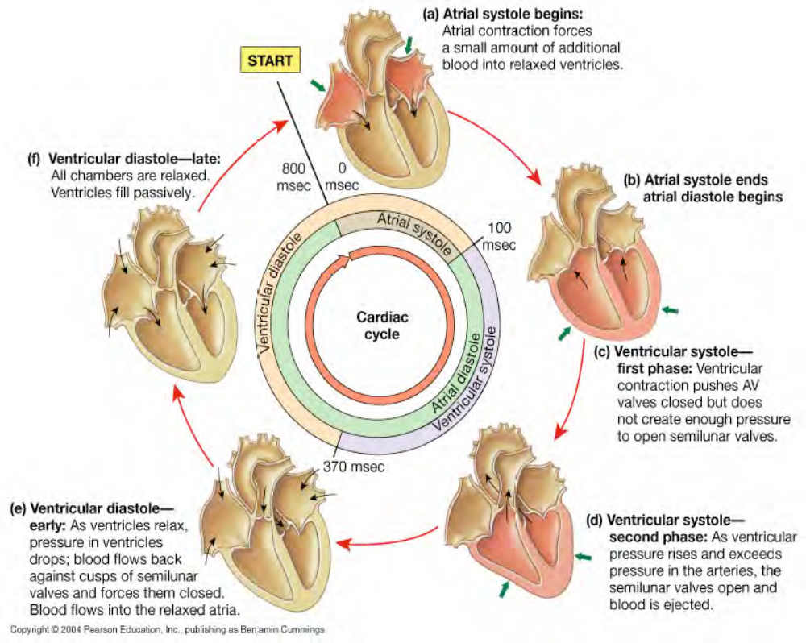

Heart Sounds:

“lubb” - S1: AV valves close at start of ventricular systole

“dupp” - S2: semilunar valves close at start of ventricular diastole

Events Occurring During the Cardiac Cycle:

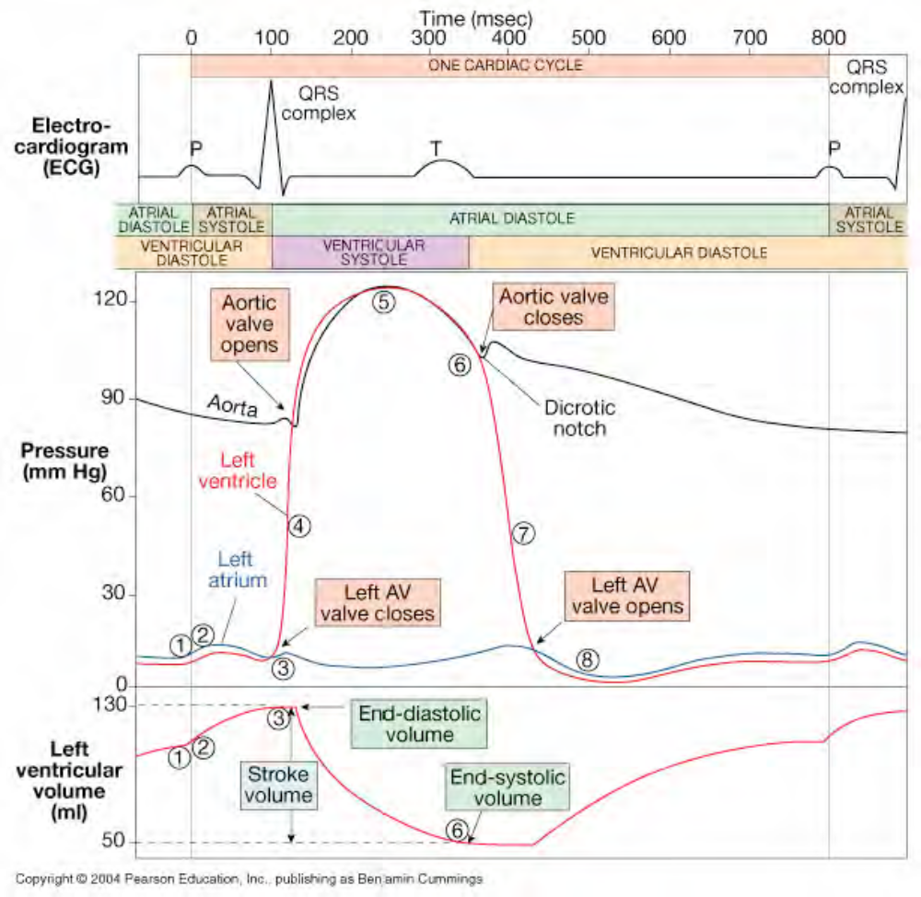

Cardiac Output: See Blood Pressure Regulation Lecture

Heart Rate Effectors:

1. Autonomic Innervation
-SA node, AV node and atrial myocardium innervated by both sympathetic (NE) and
parasympathetic (Ach) nerve fibers equally.

-Sympathetic dominates in ventricles.

-Cardiac centers in medulla oblongata monitor BP and gasses to adjust HR:
A. Cardioacceleratory center -sympathetic
B. Cardioinhibitory center –parasympathetic

-Parasympathetic tone reduce rate of SA node:
72-80bpm female
64-72bpm male
40bpm athletes

2. Hormones
-Epinephrine, Norepinephrine, Thyroxine –all increase HR by acting at SA node

-Beta blockers- drugs to treat hypertension, block Β-receptors for E / NE thus preventing
sympathetic stimulation

3. Other Heart Rate Effectors:
- Caffeine: rapid depolarization of SA node, increases HR

- Nicotine: stimulates sympathetic neurons, increases HR

- Hyperkalemia: high K+, inhibits repolarization, beats weak, heart can stop

- Hypokalemia: low K+, hyperpolarization, cells less responsive, decrease HR

- Hypercalcemia: high Ca+, muscle cells excitable, increase HR, can cause prolonged
contraction, heart seizes

- Hypocalcemia: low Ca+, contractions weak, heart can stop

-Temperature: affects metabolic rate of cardiocytes
high temp = ↑HR
low temp = ↓HR

