CARDIOVASCULAR SYSTEM: BLOOD (Chapter 19)

Cardiovascular system = blood, heart and blood vessels (anatomical division)
Circulatory system = cardiovascular system and lymphatic system (clinical)

Blood – a fluid connective tissue
Functions of blood:
1. Distribution:
a. deliver O2 and nutrients to cells (ions, glucose)
b. remove metabolic waste
c. transport hormones to targets

2. Regulation:
a. maintain body temp → distribute heat from muscles (warm blood transported from interior to surface of body-----where it is released as heat)

b. maintain pH (blood ph 7.35 – 7.45)

c. maintain fluid volume (blood total volume = 4 – 6 L (9 – 11 pints)

3. Protection:
a. restrict loss at injury (clotting)

b. prevent infection (leukocytes) (against microorganisms & toxins)

Fun fact:
to estimate your own blood volume: 7% body weight in kg = blood in L
(1 kg = 2.2 lb)
(weight lb / 2.2) X 0.07
Composition of blood:
(Connective Tissue = cells in a liquid matrix)
Blood matrix = plasma: ~55% ->water + soluble proteins
Blood cells = formed elements: ~45%
-Erythrocytes: transport O2 -Leukocytes: < 1% defense
-Platelets: < 1% cell fragments, for clotting

Plasma:
-90% water + dissolved solutes (nutrients, gases, hormones, wastes, ions, proteins)
Colloid-----------do not settle out of solution

Plasma Proteins (~8% of total plasma)
-7.6g/100ml (5X more proteins than interstitial fluid)
-These proteins remain in plasma, not absorbed by cells for nutrients

1. Albumins (60% of plasma proteins) Produced by the liver
Functions:
-act as pH buffer for blood

-contribute to osmotic pressure of blood (keep water in blood)----------because albumin does not pass into tissue easily (water stays where needed – osmosis)

-transport fatty acids and hormones--------------things like bilirubin, thyroid hormones attach to albumin and get transported in blood)
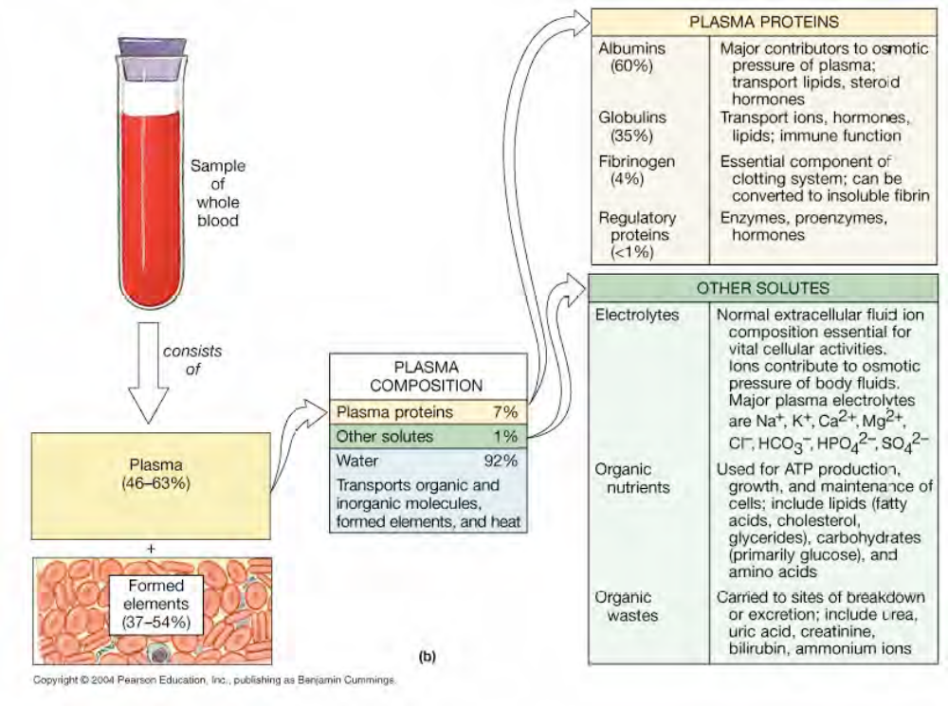
2. Globulins (35% of plasma proteins)
A. Gamma globulins / Antibodies / Immunoglobulins:
-produced by plasma cells in the lymphatic system
-function to attack foreign substances

B. Alpha and Beta globulins / Transport globulins:
-produced by the liver
-function to transport small or insoluble compounds to prevent filtration loss by kidney
Ex. Beta globulins----- plasminogen (degrades many blood plasma proteins, mostly fibrin clots)

3. Clotting Factors (4% of plasma proteins)
-produced by the liver
-11 total, fibrinogen most abundant
-all function to promote or form a clot (serum = plasma – fibrinogen)

4. Other (1% of plasma proteins)
-From liver:
-metabolic enzymes and antibacterial proteins
-From endocrine organs:
-hormones

*liver disease can lead to a variety of blood disorders (many plasma proteins produced by liver)

Hematopoiesis
Blood cell production
-all formed elements arise from the same progenitor cell: the hemocytoblast, located in the red bone marrow

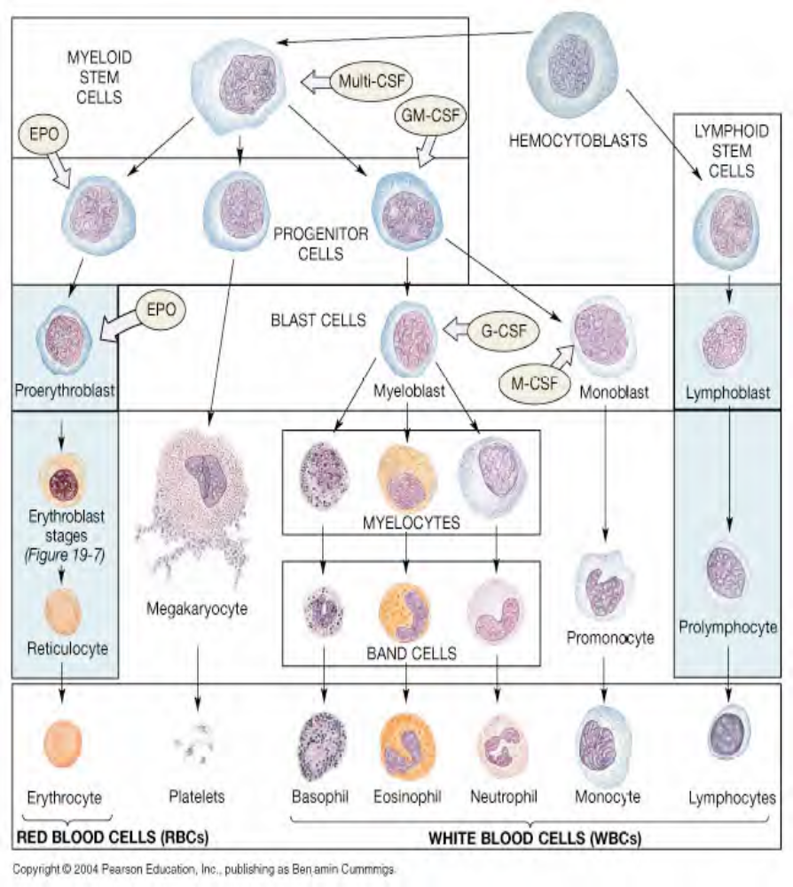
- Basophils, Eosinophils, Neutrophils and platelets exit the bone marrow to blood as mature cells.
- Monocytes must mature into Macrophages by migrating from the blood to the peripheral tissues
- Many lymphoid stem cells migrate from the bone marrow to lymphoid tissues to produce mature lymphocytes there
- Erythrocytes enter the blood as reticulocytes which mature in the bloodstream

Erythrocytes (RBCs) (700 times more numerous than WBC)
-99.9% of the formed elements of blood
-1/3 of total body cells (average human = ~75 trillion cells)
-Average RBC count = 4.2-6.3 million/μl
-RBC cannot move of their own accord; Passively moved by forces that cause blood to circulate

Hematocrit = % of whole blood occupied by formed elements (mostly erythrocytes: 99.9% )
(spins tube & heavy things go to the bottom-----RBC)
male = 46%
female = 42%

Disorder:
Polycythemia = excess erythrocytes but normal blood volume, usually due to bone marrow cancer
↑ hematocrit = ↑ viscosity = ↑ heart strain and stroke(capillaries clog, hypertension)

Erythrocyte structure
-biconcave disc
-7.8μm diameter
-large surface area for gas exchange
-can fold and stack to pass narrow vessels

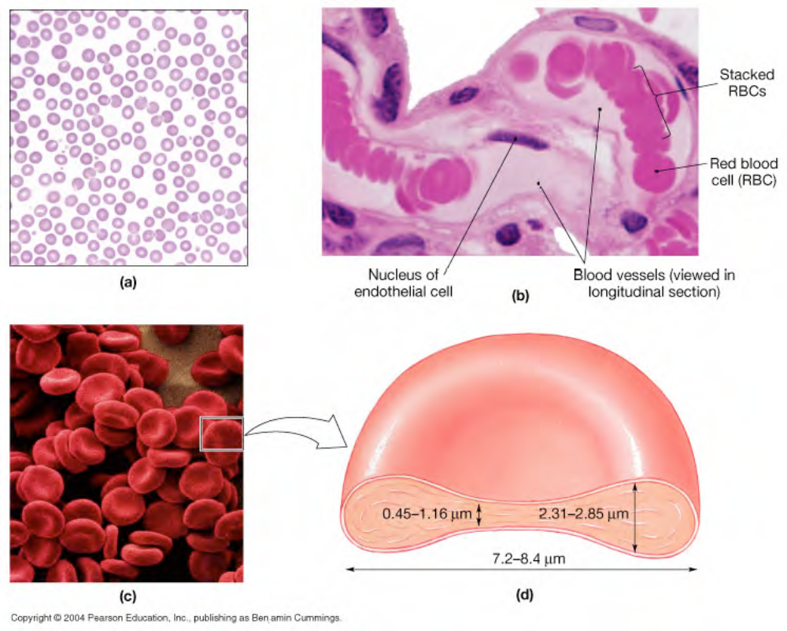

-mature erythrocytes lack all organelles
-no division, no repair --------because they lack nuclei (do not go thru mitosis)
-low metabolic demands
-life span < 120 days

-cell is 97% hemoglobin protein (red color) (also contains: lipids, ATP, carbonic anhydrase)

-hemoglobin transports O2 and some CO2

Hemoglobin Molecule (Hb) (1/3 of RBC)
- 4 globin (polypeptide chain) & 4 heme (red-pigment containing iron)

-2 α chains
-2 β chains

-each chain has one heme group with iron in center: iron binds O2
Oxyhemoglobin = O2 bound, bright red
Deoxyhemoglobin = no O2, burgundy

-three kinds:
a. embryonic hemoglobin

b. fetal hemoglobin

c. adult hemoglobin

-fetal Hb binds O2 more strongly than adult: insures transfer of O2 from mom (@ placenta)

-280million Hb/ RBC X 4 hemes/Hb, (each heme binds 1 O2) = >1 billion O2 per RBC (25 trillion RBC per person)------------2.5 million RBC destroyed every second

-most O2 is carried in blood bound to Hb (some in plasma)

-only 20% CO2 carried by Hb: Carbaminohemoglobin - CO2 bound to amino acids on
α /β chains, not on heme------other CO2 transported on bicarbonate ions with the help of enzyme carbonic anhydrase

-when plasma O2 is low, Hb releases O2 and binds CO2

-at lungs CO2 exchanged for O2 by diffusion

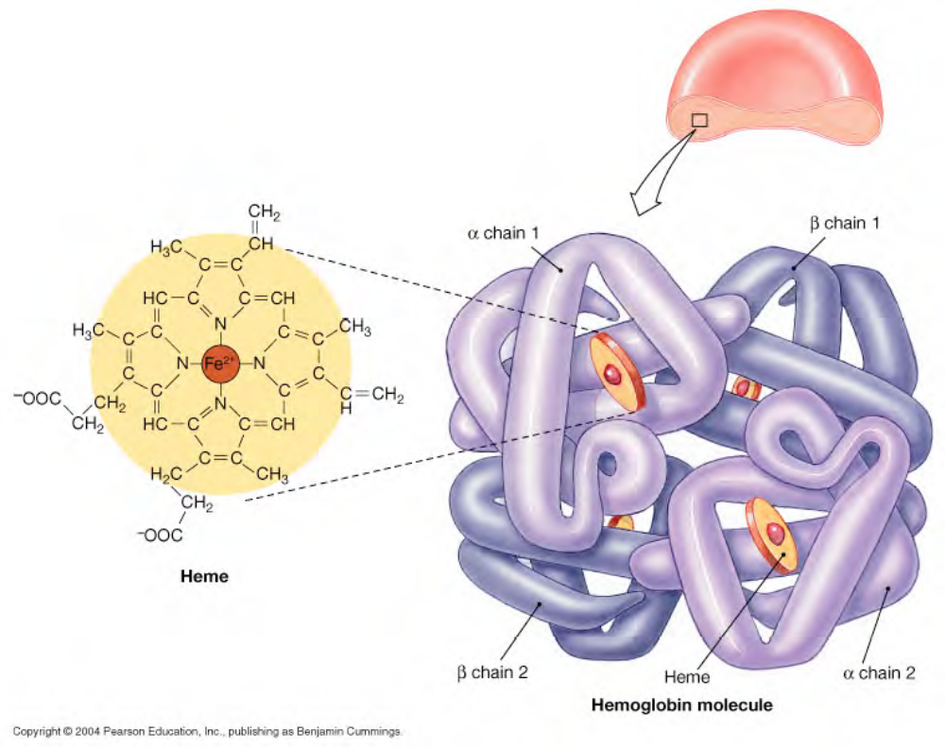

Disorder:
Anemia = deficiency of hemoglobin in the blood (O2 starvation), due to:
1. insufficient # RBCs
2. low Hb in each RBC
3. abnormal Hb
Thalassemia = inability to produce α or β chains, slow RBC production, cells fragile and short lived

Sickle-cell anemia = single amino acid mutation in β chain
high O2, cells normal
low O2, Hb misfolds, RBCs deform into crescent shape: fragile, blocks capillaries

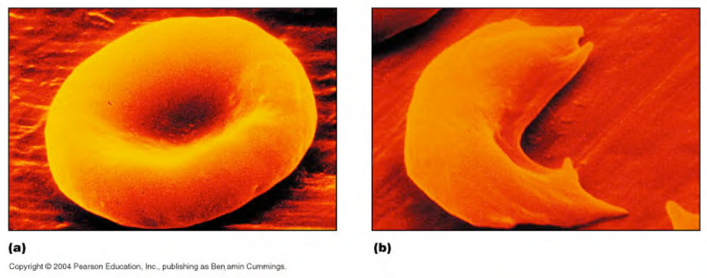
Erythropoiesis = red blood cell formation

-2 million/ sec (1 oz new blood per day)
-occurs in reticular CT in red bone marrow, in spongy bone

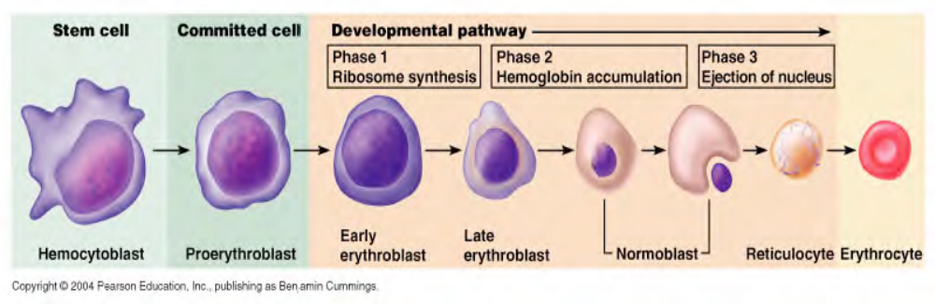

1. Hemocytoblast differentiates into myeloid stem cell
2. followed by many stages of differentiation, all involve ↑ protein synthesis
3. cell fills with Hb, loses organelles (nucleus too)
4. 3-5 days reticulocytes are formed (Hb + some ribosomes), released into blood, 1-2% of total blood RBCs
5. 2 days in circulation lose ribosomes (no more protein synthesis) = mature erythrocyte

-Vitamin B12 necessary for erythropoiesis for stem cell division
Lack B12 = pernicious anemia

Erythropoietin (EPO)
-hormone, released by kidney during hypoxia (low O2)

-stimulate RBC production:
-↑ cell division rates (up to 30million/sec)
-↑ Hb synthesis = ↓ maturation time

“blood doping” = injecting EPO or RBCs to enhance athletic performance: ↑ O2 to tissues, but also ↑ hematocrit/viscosity = clots, stroke, heart strain

-Kidney failure often = low RBCs due to lack of EPO

Erythrocyte Recycling
-old/damaged RBCs removed by phagocytes in spleen ------specifically, macrophages (they have lysosomes---digestive enzymes)

-replaced by new, ~1% turnover per day

-phagocytosed cells broken down:
-protein → amino acids, released for use
-heme →
1. iron removed, bound to transferrin(blood plasma protein for iron delivery) in blood for recycling back to bone marrow (new RBCs)
2. pigment (non-iron part)→ biliverdin (green), biliverdin → bilirubin (yellow-green), released into blood, filtered by liver, excreted in bile

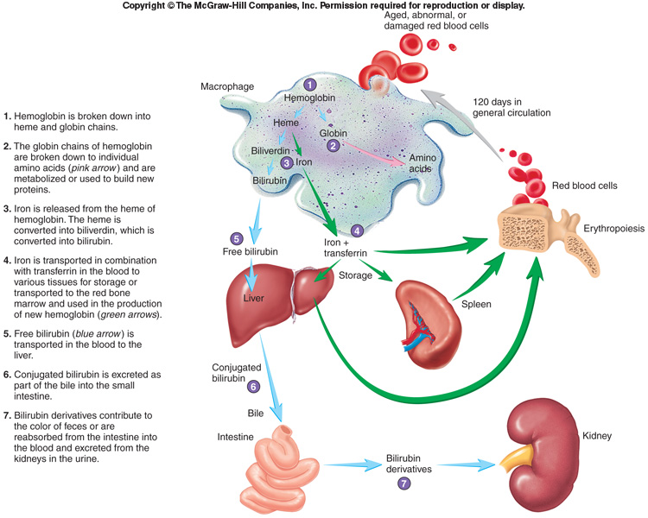

Disorder:
Jaundice = failure of bilirubin to be excreted in bile, collects in peripheral tissues −> yellow skin & eyes

3. in gut, bilirubin −>urobilins (yellow) & stercobilins (brown) via bacteria
urobilins absorbed, excreted in urine
stercobilins remain in feces

Disorder:
Hemoglobinuria = Hemolysis (RBC rupture) −−>have excess of hemoglobin so the kidney filters intact α & β chains of hemoglobin → red/brown urine
Caused by Hemolytic Anemia

Blood Types
-all cell membranes have surface antigens: indicate “self” (antigen = substance that triggers immune response)

-RBCs have 50+, 3 important for transfusion: agglutinogens: A, B, D

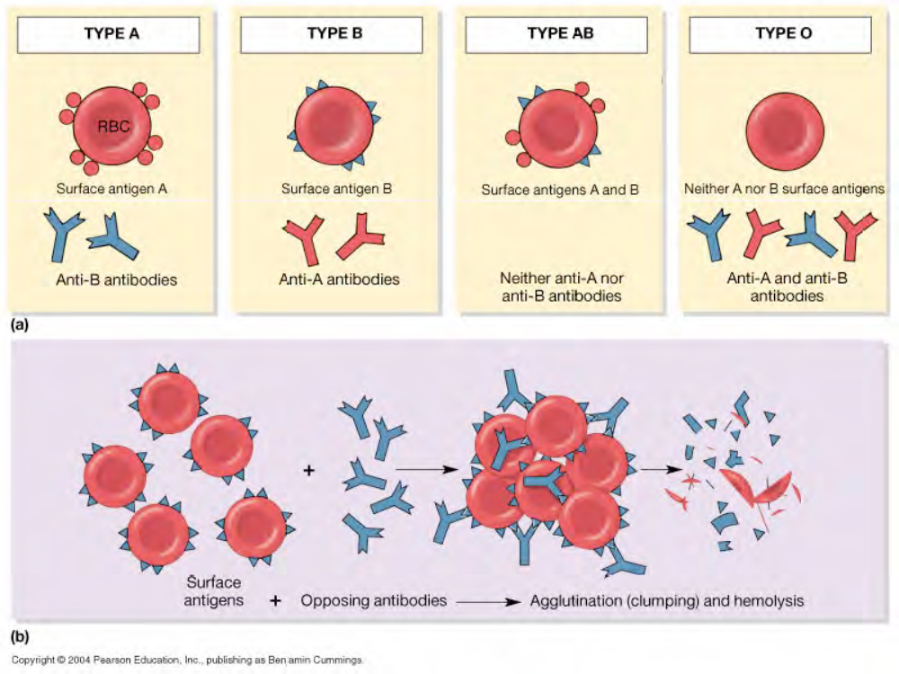

Type A blood = surface antigen A (40%)
Type B blood = surface antigen B (10%)
Type AB blood = both A + B antigens (4%)
Type O blood =neither A nor B antigen (46%)

Rh+ = surface antigen D (85%)
Rh- = no D antigen (15%)

Type A blood = antibodies against B antigen
Type B blood = antibodies against A antigen
Type AB blood = neither antibody
Type O blood = antibodies against both A & B

-at birth, blood contains antibodies against A or B antigens that are not present (2 months after birth, they are present)
-the antibodies (also called agglutinins) will cause agglutination (clumping) of antigen (agglutinogen)

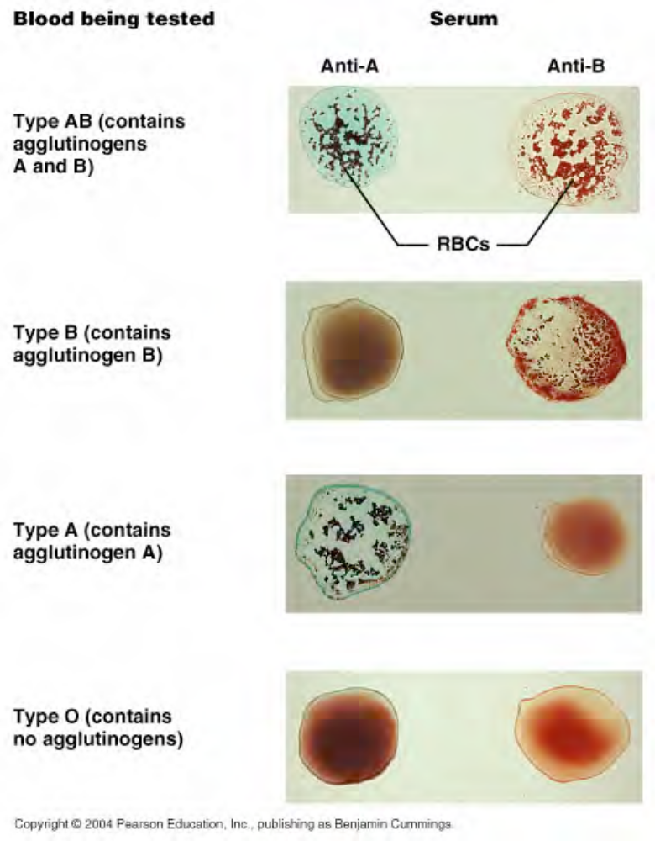
-antibodies against D antigen only form upon exposure and are small enough to cross placenta
Disorder:
Hemolytic disease of the newborn/Erythroblastosis fetalis:
Rh- mom pregnant with Rh+ baby, gets exposed to D antigen during birth, makes anti-D antibodies, pregnant with second Rh+ baby, antibodies cross placenta, causes agglutination and lysis of fetal RBCs = anemia and death

Prevention: treat mom with RhoCAM during first birth to prevent antibody formation

-blood typing always done before transfusion to prevent body wide agglutination
-if blood type unknown: type O- = universal donor: it lacks all 3 agglutinogens (A, B, D) so no risk
of agglutination by antibodies in anyone

Leukocytes (WBCs)

-< 1% total blood volume

-5 types: neutrophils, eosinophils, basophils, lymphocytes, and monocytes
-functions:
-defend against pathogens
-remove toxins and wastes
-remove abnormal/damaged cells

-all have nuclei & organelles, no hemoglobin

-6000-9000 leukocytes/μl blood

-use blood to travel to tissues, not permanent residents of blood

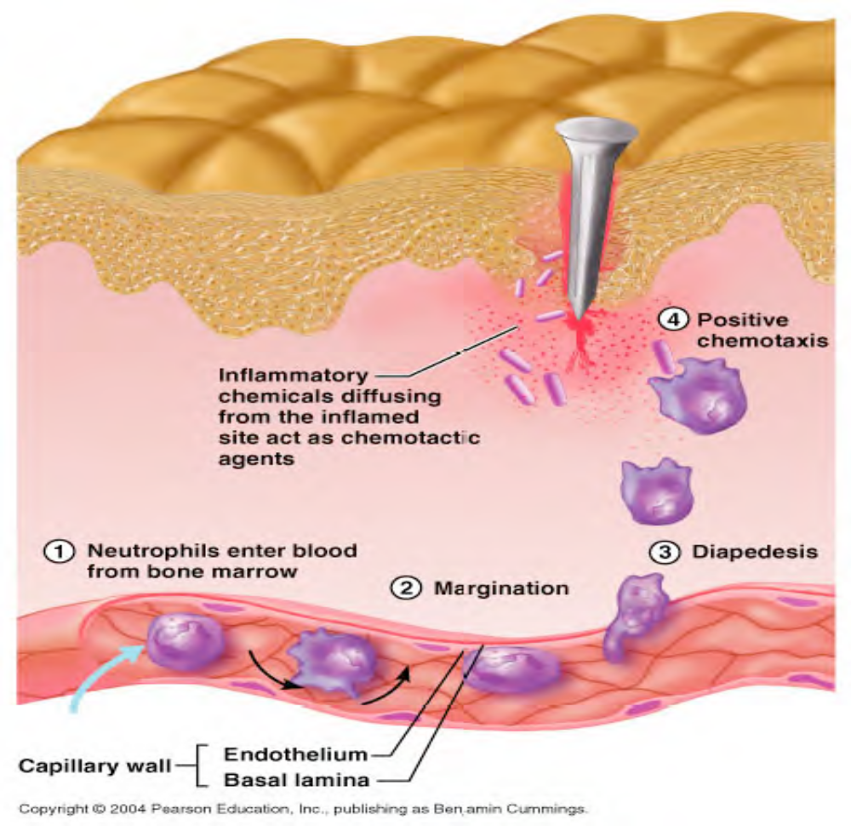
-characteristics:
1. amoeboid movement-------------- move by cytoplasmic projections

2. diapedesis (move out of blood):
a. margination = adhere to vessel
b. emigration = pass between endothelial cells

3. exhibit positive chemotaxis

4. phagocytosis: engulf pathogens and debris
Types of Leukocytes:
Granulocytes vs. Agranulocytes

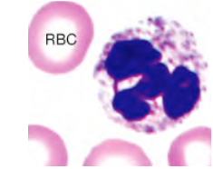

Neutrophil (a.k.a PMNs)
(polymorphonuclear leukocytes)

-Non-specific defense  -Phagocytic  -50-70% of WBCs  -3-5 lobed nucleus  -12μm diameter  -Granules contain enzymes and defensins (protein that breakdown cell-wall of bacteria)  -Very mobile: first at injury  -Life span less than 10h | Functions:  -Respiratory burst: H2O2 & O2-, kill phagocytosed  things  -Degranulation: release defensins, lyse bacteria  -Prostaglandins: induce inflammation to stop spread  of injury  -Leukotrienes: attract phagocytes

Note:

Respiratory Burst---→ Superoxide radical + Hydrogen peroxide are called reactive oxygen species. These chemicals are released when come in contact with bacteria and fungi----helps degrade them.

Prostaglandins & Leukotrienes are attracted to and release Cytokines------Signals released by endothelium cells and macrophages. They amplify the inflammatory reaction
Ex: Interleukin – 8 (recruits Neutrophils)
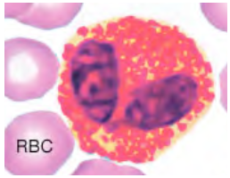

Eosinophil

-Non-specific defense  -Phagocytic  -2-4% of WBCs  -Bilobed nucleus  -12μm diameter  -Granules contain toxins  - Life span 9 d | Functions:  -Phagocytosis of antibody covered objects  -Defense against parasites: exocytose toxins  on large pathogens----attack worm parasites such as tapeworms, flukes, pinworms.  -Reduce inflammation:  anti-inflammatory  chemicals/enzymes----ex: destroy histamine which is common in tissue undergoing an allergic response.

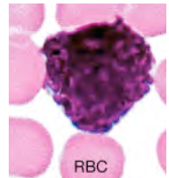

Basophil
In tissues = Mast cell

-Non-specific defense  -Not phagocytic  -Less than 1% of WBCs  -“U” shaped nucleus  -8-10μm diameter  -Granules contain  Histamine: dilate blood vessels  Heparin: prevents clotting  -Life span 9 d | Functions:  Inflammation  Allergic response (via histamine)

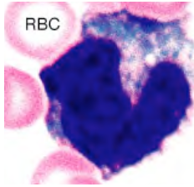

Monocyte
In tissues = Macrophage

-Non-specific defense  -Phagocytic  -2-8% of WBCs  -Kidney shaped nucleus  -15μm + diameter  -Circulate 24 h, exit to tissues = macrophage  -Life span several months | Functions:  -Phagocytosis: virus & bacteria  -Attract phagocytes  -Attract fibroblasts for scar formation  -Activate lymphocytes: to mount immune  Response  -Increase in # of Monocyte associated with chronic infections.

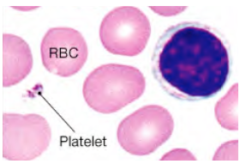

Lymphocyte

-Immune response  -20-30% of WBCs  -Large round nucleus  -5-17μm diameter  -Migratory between blood and tissues  -Most in lymphatic system(lymph nodes, spleen, tonsils, thymus)  -Life span days to lifetime | Function depends on type,  3 types:  B cells: humoral immunity (secrete  antibodies)stimulated by bacteria  T cells: cell mediated immunity (attack foreign  cells)  NK cells: immune surveillance (destroy  abnormal tissue – tumor cells

Leukopoiesis = WBC production

-Myeloid stem cells → Basophils, Eosinophils, Neutrophils, Macrophages as directed by specific colony stimulating factors (CSF) produced by
Macrophages and T cells (different CSF (hormone) results in different cell)

Leukopenia = too few WBCs
Leukocytosis = excessive WBCs in normal blood volume
normal infection ↑ WBCs from 7,500 to 11,000/μl
>100,000/μl → leukemia, cancerous stem cells, WBCs produced are immature and abnormal
Disorder:
Infectious Mononucleosis:
Epstein Bar virus infection causes production of excess agranulocytes that are abnormal, self
limiting

Platelets (Thrombocytes)
-flattened discs, 2-4μm diameter, 1μm thick
-cell fragments, no nucleus
-constantly replaced, 9-12 d in circulation, then phagocytosed by cells in spleen
-350,000 / μl blood
-1/3 of total platelets held in reserve in spleen, mobilized for crisis

Functions:
-transport clotting chemicals, release when activated
-form patch (platelet plug) over damaged vessel
-contract wound after clotting (contain actin and myosin) 2 proteins causes the clot to consolidate------edges of damaged blood vessels pull together and stops blood flow and enhances healing.

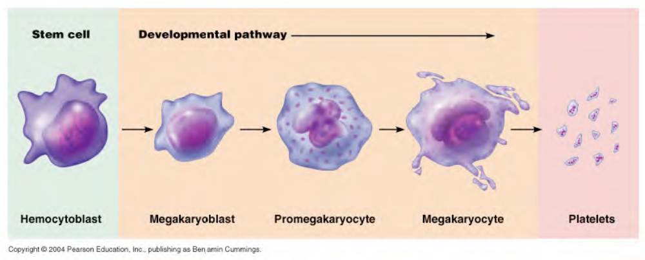

Thrombocytopoiesis = platelet production
-Megakaryocyte in bone marrow breaks off membrane enclosed cytoplasm to blood
-Each megakaryocyte can produce ~4000 platelets
-Induced by thrombopoietin from kidney and CSF from leukocytes

Thrombocytopenia = too few platelets < 80,000/μl, results in bleeding and petechia (numerous localized hemorrhages in baby; seen in mothers who ingest aspirin late in pregnancy)
Thrombocytosis = too many platelets > 1 million/μl, due to cancer or infection, clotting risk
Hemostasis:

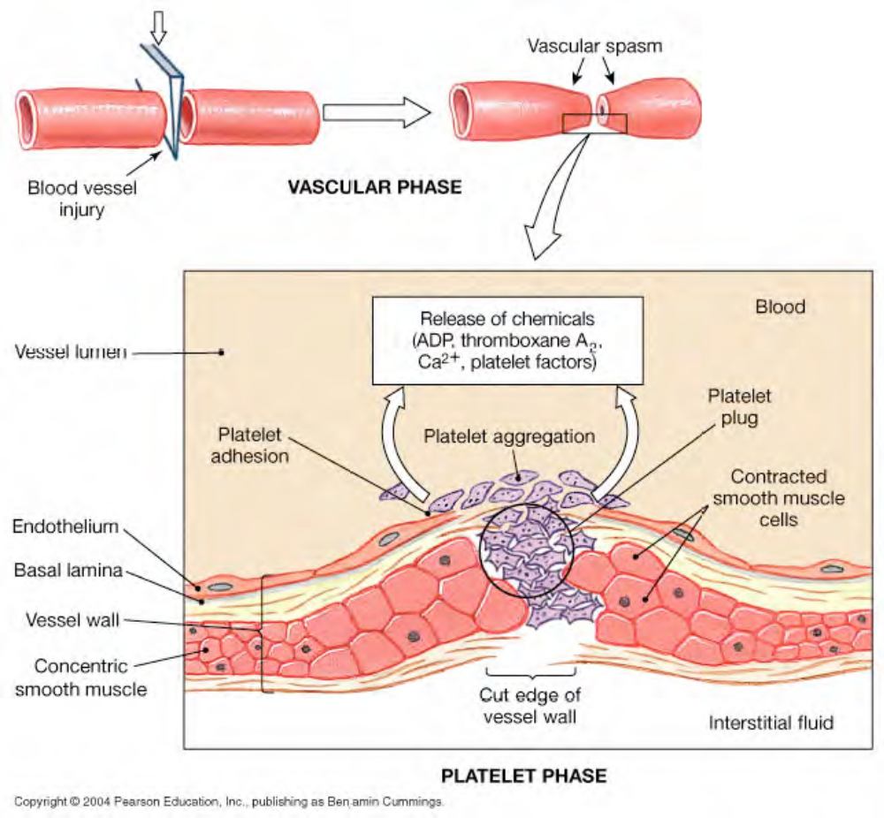

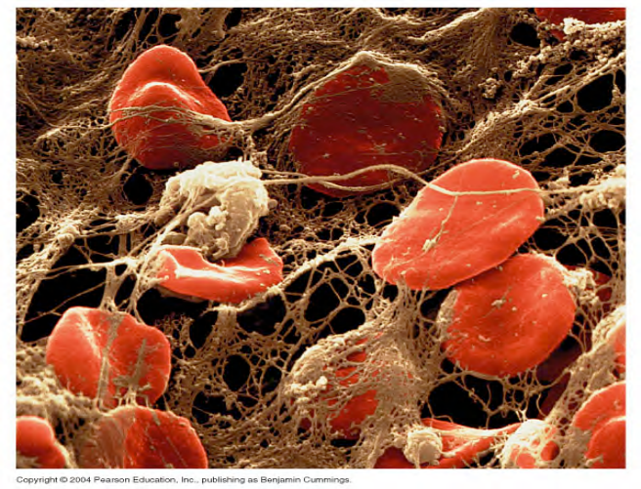

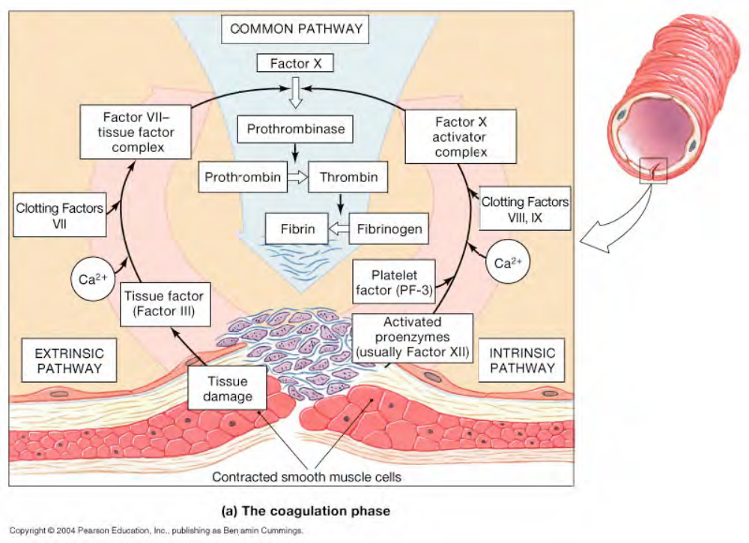

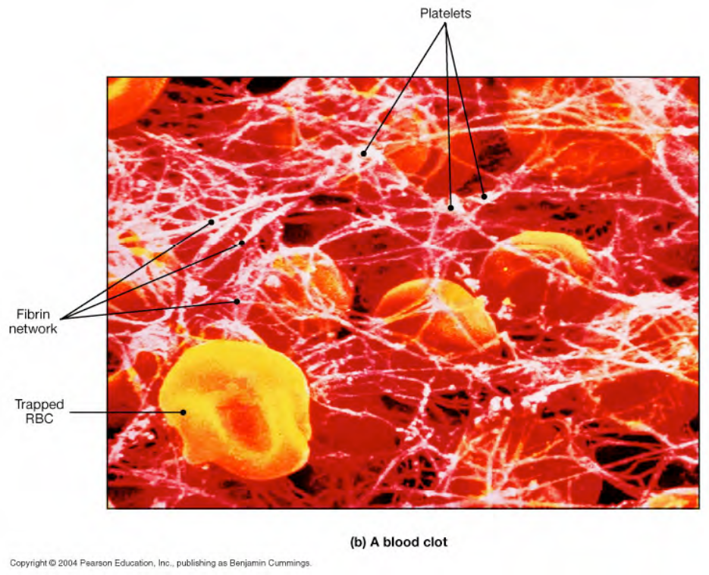

Hemostasis “stop bleeding”

Three phases:

1.) Vascular spasms -begins immediately after injury
Vasoconstriction of the vessels involved in the injury

Triggered by:
-injury to the vessel
-chemicals from damaged endothelial cells
-reflex triggered by pain receptors

Concurrently, endothelial cells release factors and hormones:
-Endothelins: stimulate vascular spasms and cell division to begin repair
-von Willebrand Factor: promotes platelet sticking to endothelium

2.) Platelet phase -begins 15 sec post injury
Platelet adhesion –platelets stick to endothelium

Platelet release reaction –after platelets adhere, they become activated,
-ADP, thromboxanes, are released and they activate other platelets

Platelet aggregation –platelets stick to each other forming a “platelet plug”
-fibrinogen receptors on activated platelets bind to fibrinogen

*Note: Platelet plug size is controlled by prostacyclin released by endothelial cells: it
inhibits platelet aggregation & activation.

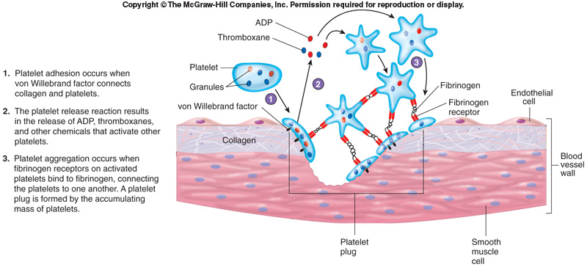
Note:
- Von Willebrand factor: Forms a bridge between collagen & platlets
- Platelets have fibrinogen receptors on them which bind to fibrinogen and this connects the platelets together.
- Activated platelets express coagulation factor V, which is important for clots.
Platelets activated by thrombin secrete: (Thrombin is a coagulation protein in blood. It converts soluble Fibrinogen into insoluble Fibrin. Fibrin is a threadlike protein fibers that traps blood cells & fluid)
-ADP: stimulates platelet aggregation and secretion
-thromboxane: stimulates vascular spasm and chemo-attract platelets
-serotonin: stimulates vascular spasm
-clotting factors (5 of the11 proteins): act in clotting cascade
-Platelet Derived Growth Factor (PDGF): promote vessel repair
-calcium ions: required for aggregation and clotting
*This sets up a positive feedback loop

3.) Coagulation -begins 30 sec post injury (it needs to be controlled so it does not spread to circulatory system)
Multistep process, three important steps:
1. Prothrombinase is formed from clotting factors
2. Prothrombinase converts prothrombin to thrombin
3. Thrombin converts fibrinogen into fibrin which forms a mesh to plug the hole
(blood “clot” = big mesh of fibrin: cells will later get trapped in it making it appear red)

Clotting Cascade

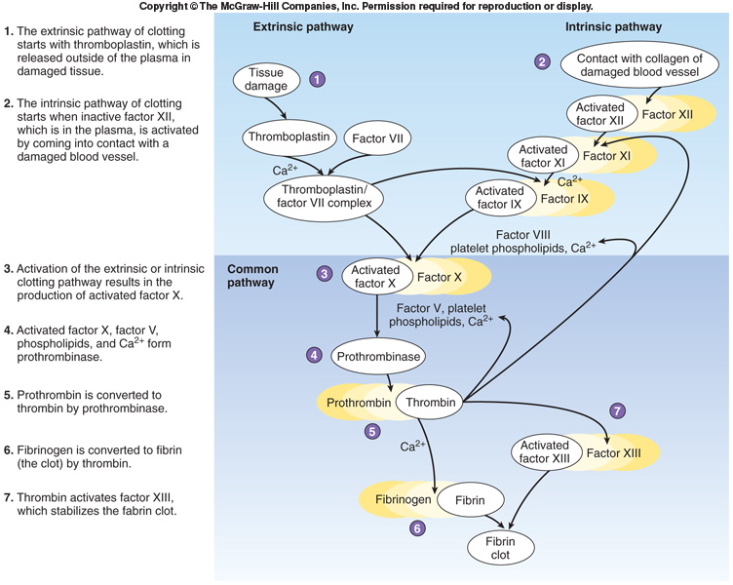
Clotting Cascade (events for coagulation)

Consists of calcium ions plus 11 proteins that each function as an enzyme to activate the next
protein in a controlled series. 5 of the 11 clotting factors are released by activated platelets and/or
endothelial cells, the remaining 6 are always present in the blood as plasma proteins produced by the liver.

Two methods to initiate clotting:

Extrinsic Pathway Intrinsic Pathway
(fast, initiated by factors outside bloodstream) (slow, initiated by factors present in (only occurs in body) blood) - (can occur in a test tube)

Factor III / Tissue Factor Factor XII
released by damaged endothelial cells activated by exposure to collagen
(or other tissue, or activated platelets) (or other charged surfaces e.g. glass)
+ causes
Factor VII + Ca2+ Factor VIII and Factor IX to combine

Common Pathway
Factor X is activated −> prothrombinase
prothrombin −> thrombin
fibrinogen −> fibrin

Fibrin forms a web that traps blood cells and platelets to seal off the wound. Thrombin has
positive feedback activity on both extrinsic and intrinsic pathways and both work together to form a
strong clot.

30-60 min post injury:
clot retraction occurs to reduce wound size
PDGF(Platelet Derived Growth Factor) stimulates cell division to promote repair

After healing has occurred:
Fibrinolysis: clot is dissolved
thrombin (common pathway) and tissue Plasminogen Activator (tPA from
dammaged tissue) activate plasminogen (in blood) to form plasmin which digests fibrin

Blood clotting normally prevented by:
1. anticoagulants in blood that inhibit clotting factors (e.g. Antithrombin III inactivates thrombin)
2. Heparin from basophils and endothelial cells activates Antithrombin III
3. Protein C from liver stimulates plasmin to digest fibrin
4. Prostacyclin from endothelial cells prevents platelet aggregation

Bleeding Disorders:
Thrombosis = clotting in undamaged vessels,
slow or prevent flow (intrinsic pathway)

Embolus = free floating thrombosis,
blocks small vessels −> tissue damage, heart attack, stroke

Disseminated Intravascular Coagulation: widespread clotting followed by systemic bleeding, rare: complication of pregnancy, septicemia or mismatched transfusion-----------------* Burns
*Get massive clot formation which uses up all clotting factors. The result is continual bleeding around wounds.

Hemophilia = inadequate production of clotting factors (genetic disorder)
Type A −> Factor VIII (X linked)-------treatment is injection of missing clotting factor
Type B −>Factor IX
Type C −>Factor XI

Other blood disorders:

Dietary:
-Calcium required for clotting cascade
-Vitamin K required for liver to synthesize clotting factors
-Iron required for hemoglobin production
-Vitamin B12 required for RBC stem cell division

Organ health:
-Impaired liver = clotting ( clotting factors)
-Impaired kidney = RBC ( EPO) platelets ( thrombopoietin)

